**Query 4 sem index:**

SELECT D.name_dependent, E.name_employee, DE.name_department

FROM Dependent AS D

INNER JOIN Employee AS E ON E.idt_dependent = D.idt_dependent

INNER JOIN Department AS DE ON DE.idt_department = E.idt_department

ORDER BY DE.name_department

Relatório do plano de consulta a partir do comando explain do Postgress:

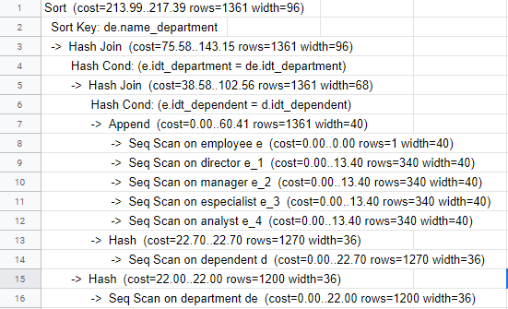

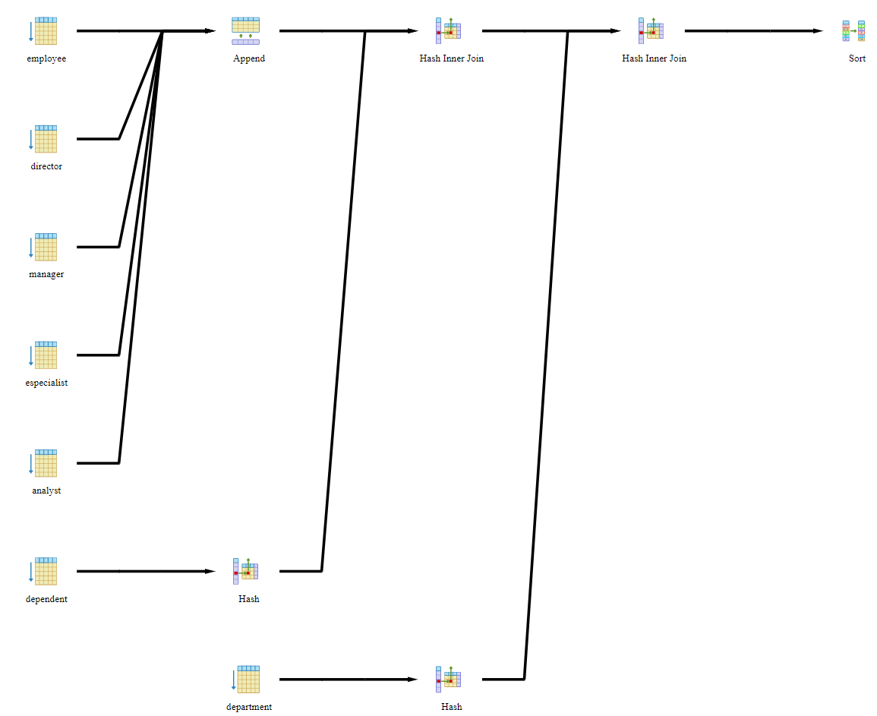

**query 4 com index:**

CREATE INDEX indicePrimeiraQuery

ON Employee (idt_employee, name_employee);

CREATE INDEX indicePrimeiraQueryTeam

ON Team (idt_team, name_team);

Relatório do plano de consulta a partir do comando explain do Postgress:

